DISPLAY BOOKSHELVES PROJECT

Software Requirements Specification

|  |  |  |  |
| --- | --- | --- | --- |
|  | Prepared By | Reviewed By | Approved By |
| Name | Ravi Kumar | Deva Thilagai |  |
| Role | CSD Interns | Batch Trainer |  |

**Table of Contents**

Table of Contents………………………………………………………….….......II

1. Introduction………………………………………………………………….…1

1.1 Intended Audience……………………………………………….......1

1.2 Project Scope…………………………...……………………………1

2. Overall Description…………………………………………….……………….1

2.1 Operating Environment……………………...……………………....1

3. Requirements……………………………………………………………...…….1

3.1Login………………………………………………………………….2

3.1.1Description………………………………………………....2

3.1.2 Functional Requirements……..…………………………...2

**1. Introduction**

UrbanLadder is an online furniture sore website. We are taking and testing three functionalities of that website (i.e.)

* Bookshelves product filtering
* Categories for product filtering
* Error messages on invalid input for Gift Card section

**1.1 Intended Audience**

* Business Unit (BU) SME
* Academy coach
* Technical Trainer

**1.2 Project Scope**

This document defines at a functional level the business activities that are encompassed by the system and the rules that apply to them. It also encompasses some of the key high- and low-level technical requirements of the system.

It draws heavily on both the proposed Framework and Business Rules and the Technical Architecture documents. The scope of the detailed analysis project phase specifies that this document will include.

* Classification of requirements according to their functional areas.
* A description of each process in the system, including their inputs, outputs, and data transformation rules.

**2. Overall Description**

**2.1 Operating Environment**

* Windows operating system
* Web application

**3. Requirements**

This part of the requirements document serves to present the Bookshelves product filtering, categories for product filtering and error messages on invalid input for Gift Card section.

**3.1.1 Functional Requirements**

**3.1.1.1 Req0001**

**Req0001a-**The user enters ‘Bookshelves’ in the search bar present on home page

**Req0001b**-The user clicks ‘search’ button next to the search bar

**Req0001c**-The user selects the ‘price’ filter that price less than 15000.

**Req0001d-** The user selects ‘Exclude out of Stock, check box.

**Req0001e-** The user then gets the first 3 bookshelves name and price after all the filters are applied.

**3.1.1.2 Req0002**

**Req0002a**- The user navigates to the ‘trending’ tab in home page.

**Req0002b-** The user then mouse hover to the ‘UL Collections’ present in trending

**Req0002c-** The user clicks ‘Category’ option to see the drop down of category lists of collections.

**Req0002d-** Then the user should get that list present in category drop down.

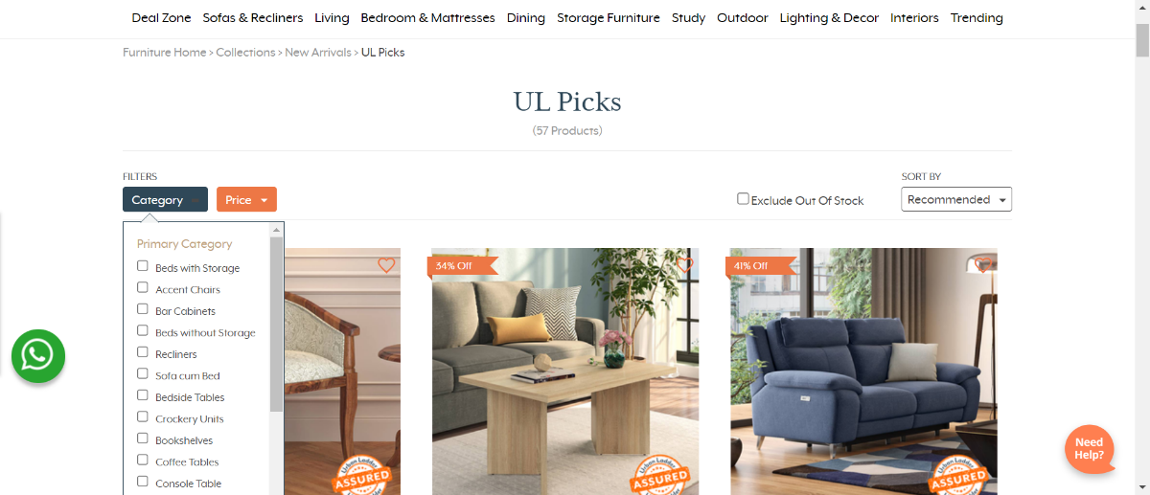

**3.1.2.3 Req0003**

**Req0003a**-The user navigates to home page and click on the Gift Cards.

**Req0003b-** The user selects the Birthday / Anniversary option from categories.

**Req0003c-**The user then chooses the price of the gift card and click on Next button.

**Req0003d-**The user then fills the mandatory fields and clicks the ‘Confirm’ button.

**Req0003e-**The user then clicks ‘Proceed to Payment’ and gets the error message of invalid email and capture it.

